Weekly Status Report
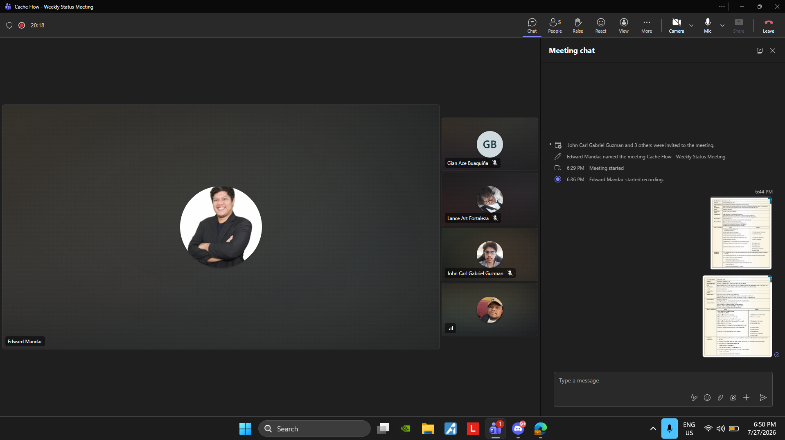
Minutes of Meeting
Date: 07-27-2028
Meeting Called By: Cache Flow
Facilitator: Edward Mandac
Link of the Meeting: Cache Flow - Weekly Status Meeting-20260727_183626-Meeting Reco rding.mp4

1. Attendees
Gian Ace Buaquiña
Beejay A. Carpio
Lance Art P. Fortaleza
John Carl Gabriel Guzman
2. Agenda
* What are the deliverables this week
- System Context Diagram
- Use Case Diagram
- Use Case Full Description
- User Stories and Acceptance Criteria
- Submit all deliverables on GitHub
3. Summary
* Status update for the week
- Currently working on organizing folders for Github , finishing System Context Diagram and Uploading Use Case Diagram and User Stories and Acceptance Criteria.
* Blockers/Obstacle that encounter this week
- Our groupmate (Gian Ace Buaquiña) doesn’t have access to our GitHub Repo.

